IWA 2000 – New Products

P99 QA (Quick Action)

The pistol P99 QA is a P99 with a new quick action trigger. This trigger system required by some law enforcement agencies ensures constant trigger performance from the first to the last shot. The P99 QA is ready to fire immediately after retraction of the slide although four
independently operating safeties guarentee maximum safety for the user.

With the QA-trigger, the striker is in a precocked position (approx. 0,24”), and further pulling of the trigger results in additional cocking of approx. 1/8” before discharge.
Trigger travel is approx. 0,24” with trigger pull of approx. 6.5 lbs.
The P99 QA features a specially designed smaller decocking lever ensuring safe decocking for disassembly or safe storage. In order to prevent an unintentional decocking the decocking lever operates only by using auxiliary material like a ballpen or a handcuff key, for example.
Otherwise, the P99 QA features all the advantages of the standard P99.

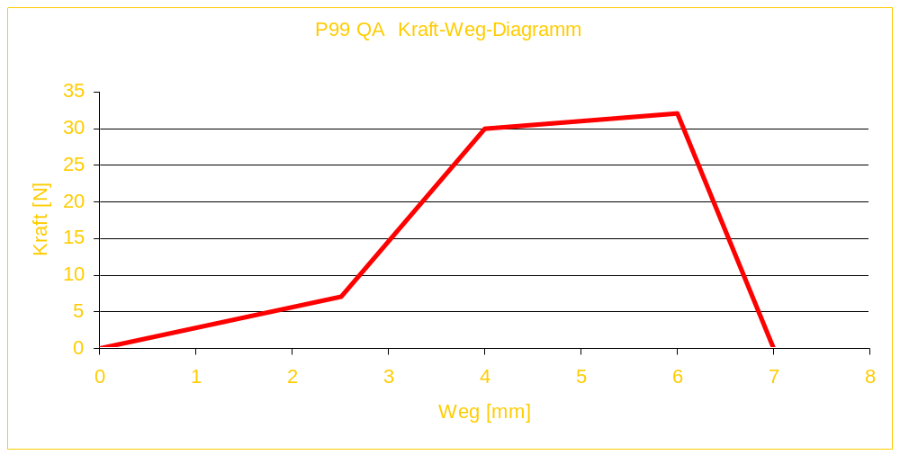

Carl Walther GmbH
- Sales Dept. Arnsberg -

